Banking Dashboard
Problem Statement –
Develop a basic understanding of risk analytics in banking and financial services and understand how data is used to minimise the risk of losing money while lending to customers.
Solution –
With our dashboards which are created using Power BI latest tools helps the company to make a decision based on the applicant’s profile like if the applicant is likely to repay the loan then approving the loan otherwise not.

1. Project Overview
This project focuses on risk analytics in banking, aiming to understand how financial institutions use customer data to reduce the risk of financial loss while lending. The main objective is to analyze customer financial behavior and identify patterns that distinguish low-risk (safe) and high-risk (risky) borrowers.
Using Python (EDA) and Power BI dashboards, the project enables data-driven decision-making. It helps banks evaluate whether a customer is likely to repay a loan based on factors like income, credit usage, deposits, and account activity.
The system ultimately supports:
- Better loan approval decisions
- Risk-based customer segmentation
- Reduced chances of loan defaults

2. Dataset Summary
The dataset consists of banking and customer-related information stored across multiple interconnected tables such as:
- Client-Banking
- Banking Relationship
- Gender
- Investment Advisor
- Period

Key Features in Dataset
- Estimated Income
- Bank Deposits
- Bank Loans
- Credit Card Balance
- Savings & Checking Accounts
- Number of Credit Cards
- Demographics (Gender, Nationality, Occupation)

Data Preparation Steps
- Imported data using CSV & MySQL
- Checked structure using:
  - head()
  - info()
  - describe()
- Created new features:
  - Income Bands (Low, Medium, High)
  - Engagement Days (customer duration with bank)
  - Processing Fees (based on fee structure)
These features help in better segmentation and risk evaluation.

3. EDA Using Python
Exploratory Data Analysis (EDA) was performed using Python libraries like Pandas, Matplotlib, and Seaborn (from your notebook).

1. Univariate Analysis
- Count plots for:
  - Gender
  - Nationality
  - Credit card count
Insight:
- Helps understand customer distribution and demographics.

2. Bivariate Analysis
- Compared financial variables with categories (e.g., nationality)
Insight:
- Financial behavior differs across customer segments
- Useful for targeted risk strategies

3. Income Band Analysis
Customers grouped into:
- Low Income → High risk
- Medium Income → Moderate risk
- High Income → Low risk
Insight:
- Income is a strong indicator of repayment ability

4. Numerical Analysis
- Histograms for:
  - Income
  - Savings
Insight:
- Data is skewed → wealth is unevenly distributed

5. Correlation Analysis (Heatmap)
- Relationships analyzed between:
  - Income
  - Deposits
  - Loans
  - Credit usage
Key Findings:
- Income ↑ → Deposits ↑ → Safer customers
- Credit usage ↑ + Loans ↑ → Higher risk
6. Key Risk Indicators
Low Risk Customers:
- High income
- High deposits
- Low credit usage
High Risk Customers:
- High credit card balance
- Multiple loans
- Low savings

4. Business Recommendations
Based on analysis, the following strategies are recommended:

Loan Approval Strategy
- Approve loans easily for high-income + high-deposit customers
- Perform strict checks for high credit usage customers

Risk-Based Pricing
- Assign higher interest rates to risky customers
- Offer lower rates to stable customers

Customer Segmentation
- Segment customers into:
  - Low risk
  - Medium risk
  - High risk

Credit Monitoring
- Monitor customers with:
  - High credit card balances
  - Multiple loans

Personalized Banking
- Offer customized products based on:
  - Income level
  - Financial behavior

Business Impact
- Reduced loan defaults
- Improved profitability
- Better decision-making using data

Data Cleaning –
Creating a new column Engagement Timeframe in client-banking column which tells about the time line of the clients in banks
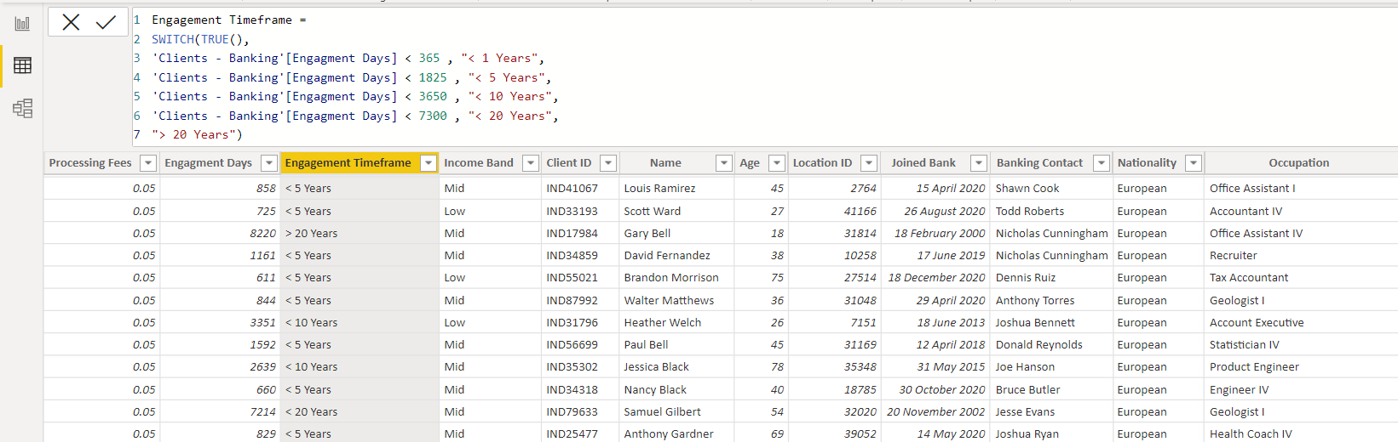

Creating a new column Engagment Days in Client-Banking table how many days the client spent from the date of joining in banks
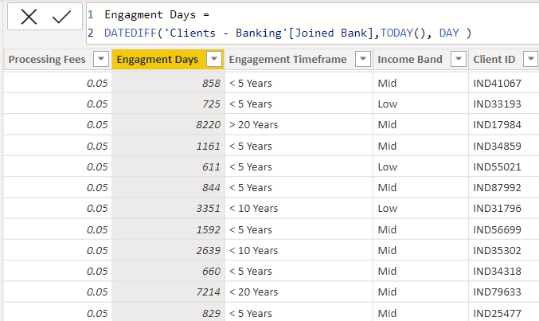
Creating bins for the Estimated Income < 100000 as low and <300000 as Mid with the column named as Income Band in Clients-Banking table.
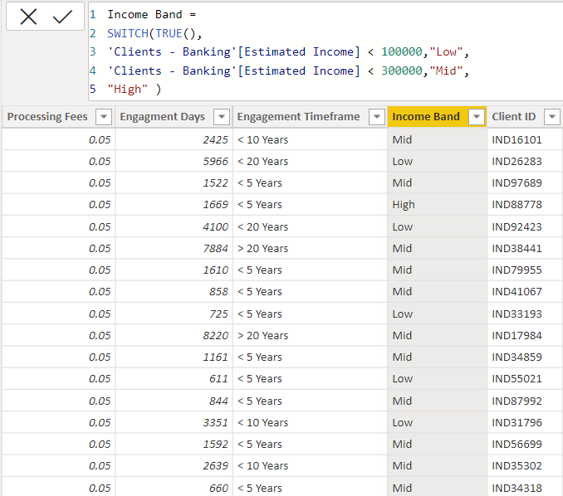

Creating a new column named as Processing Fees for the column Fee Structure like if fee structure is high then processing fee would be 0.05
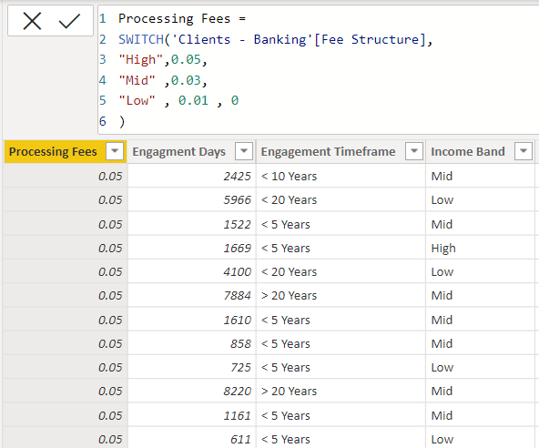
Calculated Functions –
Sum :
The power bi sum function will add all the numbers in a column and the column contains numbers to sum. It returns a decimal number.
Syntax :
Sum= SUM(<column>)
Example:
Bank Deposit =
SUM('Clients - Banking'[Bank Deposits] )

DistinctCount :

Counts the number of distinct values in a column

Syntax:

DISTINCTCOUNT(<column>)

Example :

Total Clients = DISTINCTCOUNT('Clients - Banking'[Client ID] )

Sumx :

Returns the sum of an expression evaluated for each row in a table.

Syntax:

SUMX(<table>, <expression>)

Example :
Total Fees = SUMX('Clients - Banking' , [Total Loan] * 'Clients - Banking'[Processing Fees] )

Switch :

Evaluated an expression against a list of values and returns one of multiple possible result expressions

Syntax :

SWITCH(<expression>, <value>, <result>[, <value>, <result>]…[, <else>])

DATEDIFF :

Returns the number of interval boundaries between two dates.

Syntax :

DATEDIFF(<Date1>, <Date2>, <Interval>)

Example :

Engagment Days = DATEDIFF('Clients - Banking'[Joined Bank],TODAY(), DAY )

KPI’S:

In which followings KPIS are present :

Total Clients :

Total Clients KPI represents total number of clients in banking.

Total Clients = DISTINCTCOUNT('Clients - Banking'[Client ID] )

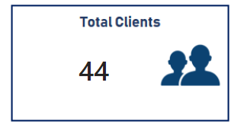

Total Loan :

Total Loan gives you information about the bank loan + Business lending + credit cards balance of particular investor , gender.

Total Loan = [Bank Loan] + [Business Lending] + [Credit Cards Balance]

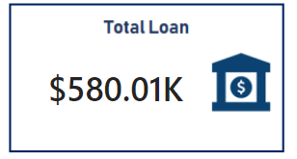

Bank Loan :

Bank Loan gives you information what is the loan amount of loan to be repaid by the client to bank.

Bank Loan = SUM('Clients - Banking'[Bank Loans] )

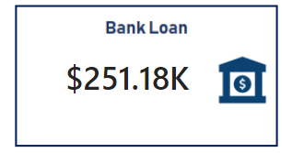

Business Lending :
Business lending gives you information about the loan amount given to small business.
Business Lending = SUM('Clients - Banking'[Business Lending] )

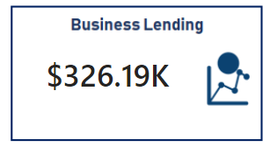

Total Deposit
Total Deposit gives you information about the amount deposited by particular investors in bank
Total Deposit = [Bank Deposit] + [Savings Account] + [Foreign Currency Account] + [Checking Accounts]

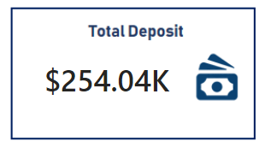

Total Fees :
Total Fees is nothing but the amount charged by the bank for account set-up , maintenance charges etc.
Total Fees = SUMX('Clients - Banking' , [Total Loan] * 'Clients - Banking'[Processing Fees] )

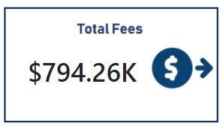
Bank Deposit :
Bank deposit is the money put in the bank.
Bank Deposit =
SUM('Clients - Banking'[Bank Deposits] )

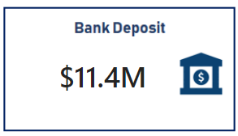

Checking Account Amount :
Checking account amount is nothing but which offers easy access to your money for daily transactional needs.
Checking Accounts =
SUM('Clients - Banking'[Checking Accounts] )

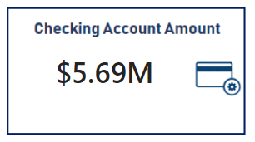
Total CC Amount :
Total CC Amount is a short-term source of financing for a company by a bank.
Total CC Amount = SUM('Clients - Banking'[Amount of Credit Cards] )

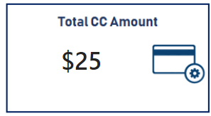
Saving Account Amount :
A savings account is an interest-bearing deposit account held at a bank.
Savings Account = SUM('Clients - Banking'[Saving Accounts] )

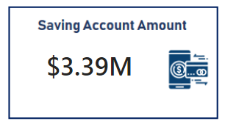

Foreign Currency Amount :
Foreign Currency Account means an account held in a currency that is not the currency of India or Bhutan or Nepal.
Foreign Currency Account =
SUM('Clients - Banking'[Foreign Currency Account] )

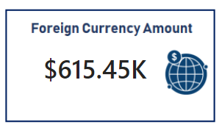
Engagement Account :
Engagement Banking is nothing but puts the customer at the center and aims to deliver the digital experiences they expect.
Engagment Length =
SUM('Clients - Banking'[Engagment Days])

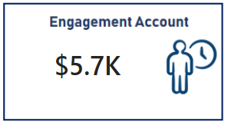
Credit Cards Balance :
It is the total amount of money currently owned by a cardholder to their credit card bank.
Credit Cards Balance = SUM('Clients - Banking'[Credit Card Balance] )

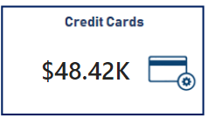

Visualization And Result –
Home
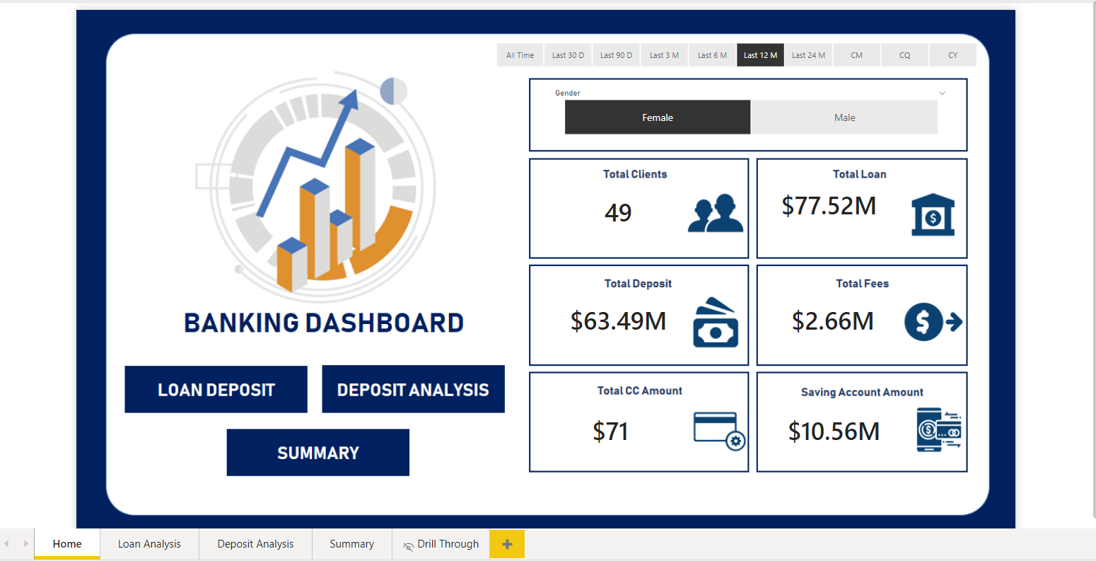
Loan Analysis
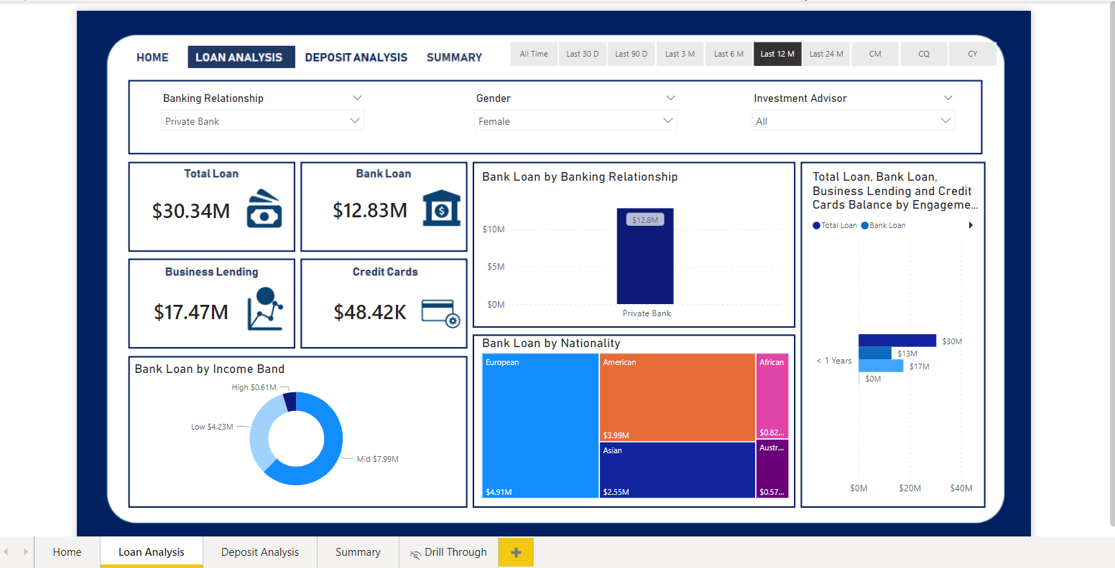

Deposit Analysis
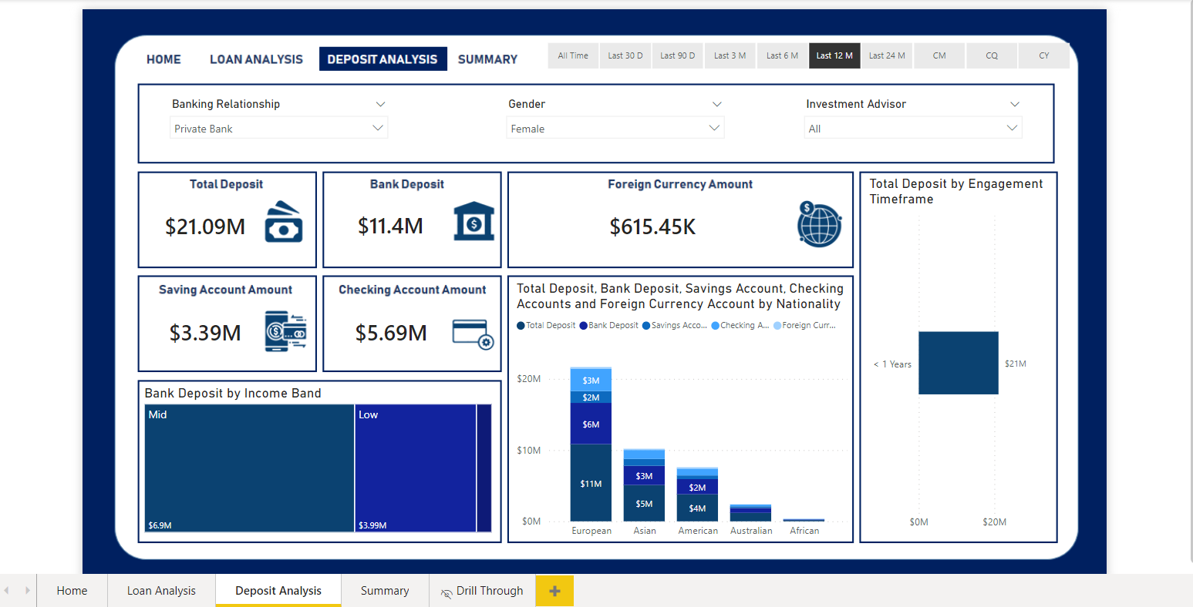
Summary Dashboard
